**Worksheet 1.1**

**Student Name:** Sahil Kaundal **UID:** 21BCS8197

**Branch:** CSE (Lateral Entry) **Section/Group:** 20BCS-809_A

**Semester:** 4th  **Date of Performance:** 10/02/2022

**Subject Name:** Computer Networks **Subject Code:** 20CSP-257

**1. Aim/Overview of the practical:**

Create a worksheet which elaborates the different transmission medias and steps to create the connector to make a ethernet connection possible.

**2. Task to be done/ Which logistics used:**

Which elaborates the different transmission medias and steps to create the connector to make a ethernet connection possible.

**3. Steps for experiment/practical/Code**

# Types of Transmission Media:

In data communication terminology, a transmission medium is a physical path between the transmitter and the receiver i.e. it is the channel through which data is sent from one place to another.

Transmission Media is broadly classified into the following types:

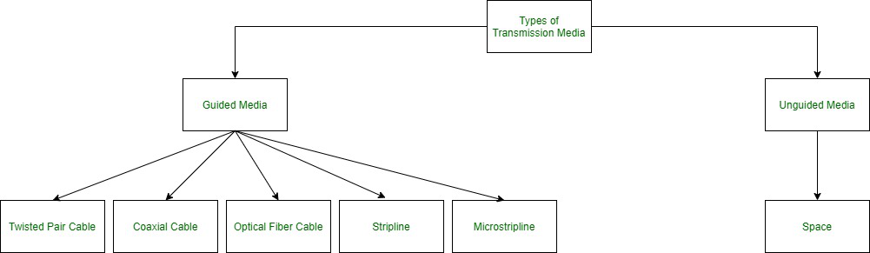

1. **Guided Media:**   
   It is also referred to as Wired or Bounded transmission media. Signals being transmitted are directed and confined in a narrow pathway by using physical links.

**Features:**

* High Speed
* Secure
* Used for comparatively shorter distances

There are 3 major types of Guided Media:

**(i) Twisted Pair Cable –**   
It consists of 2 separately insulated conductor wires wound about each other. Generally, several such pairs are bundled together in a protective sheath. They are the most widely used Transmission Media. Twisted Pair is of two types:

* **Unshielded Twisted Pair (UTP):**   
  UTP consists of two insulated copper wires twisted around one another. This type of cable has the ability to block interference and does not depend on a physical shield for this purpose. It is used for telephonic applications.



**Advantages:**

Least expensive

Easy to install

High-speed capacity

Susceptible to external interference

Lower capacity and performance in comparison to STP

Short distance transmission due to attenuation

* **Shielded Twisted Pair (STP):**   
  This type of cable consists of a special jacket (a copper braid covering or a foil shield) to block external interference. It is used in fast-data-rate Ethernet and in voice and data channels of telephone lines.

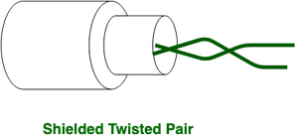

**Advantages:**

Better performance at a higher data rate in comparison to UTP

Eliminates crosstalk

Comparatively faster

Comparatively difficult to install and manufacture

More expensive

Bulky

**(ii) Coaxial Cable –**   
It has an outer plastic covering containing an insulation layer made of PVC or Teflon and 2 parallel conductors each having a separate insulated protection cover. The coaxial cable transmits information in two modes: Baseband mode(dedicated cable bandwidth) and Broadband mode(cable bandwidth is split into separate ranges). Cable TVs and analog television networks widely use Coaxial cables.

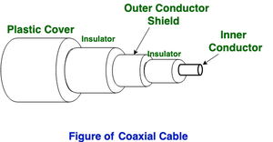

**Advantages:**

High Bandwidth

Better noise Immunity

Easy to install and expand

Inexpensive

**Disadvantages:**

Single cable failure can disrupt the entire network

**(iii) Optical Fiber Cable –**   
It uses the concept of reflection of light through a core made up of glass or plastic. The core is surrounded by a less dense glass or plastic covering called the cladding. It is used for the transmission of large volumes of data.

The cable can be unidirectional or bidirectional. The WDM (Wavelength Division Multiplexer) supports two modes, namely unidirectional and bidirectional mode.

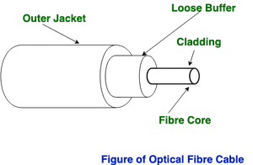

**Advantages:**

Increased capacity and bandwidth

Lightweight

Less signal attenuation

Immunity to electromagnetic interference

Resistance to corrosive materials

**Disadvantages:**

Difficult to install and maintain

High cost

Fragile

1. **Unguided Media:**   
   It is also referred to as Wireless or Unbounded transmission media. No physical medium is required for the transmission of electromagnetic signals.

**Features:**

The signal is broadcasted through air

Less Secure

Used for larger distances.

* **Steps to create the connector to make a ethernet connection possible.**

**1**

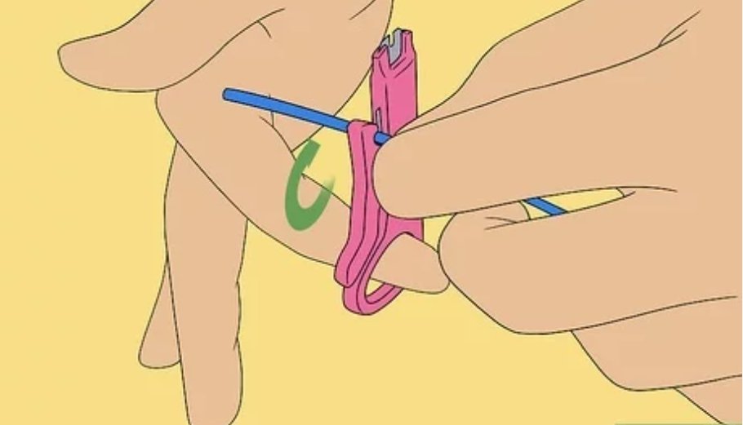

**Strip your cable.** Use your cable strippers at about 1-2 inches from the end of the cable to remove the outer jacket.

**2**

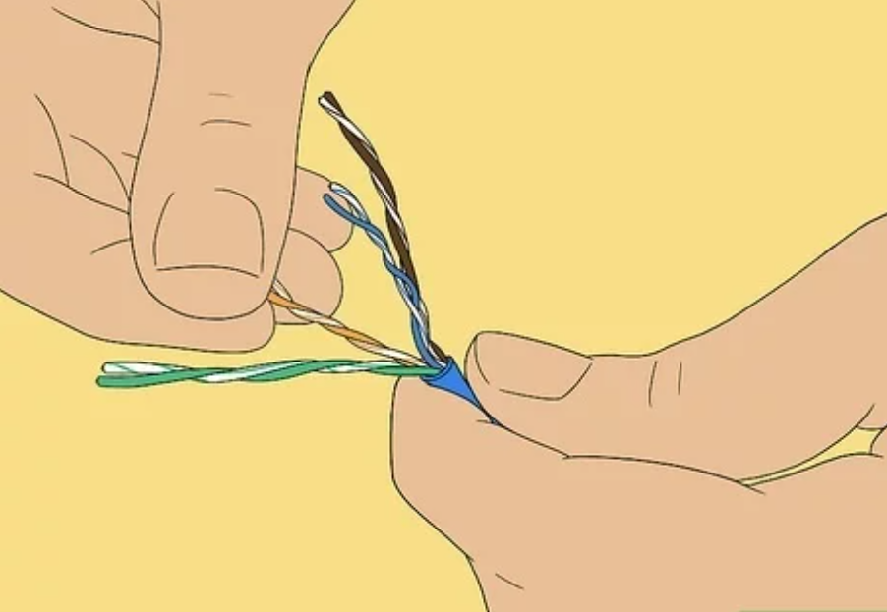

**Untwist the twisted pair wires all the way back to the jacket.** This can be done just like a regular twist-tie on a loaf of bread, but with four of them of different colors.

**3**

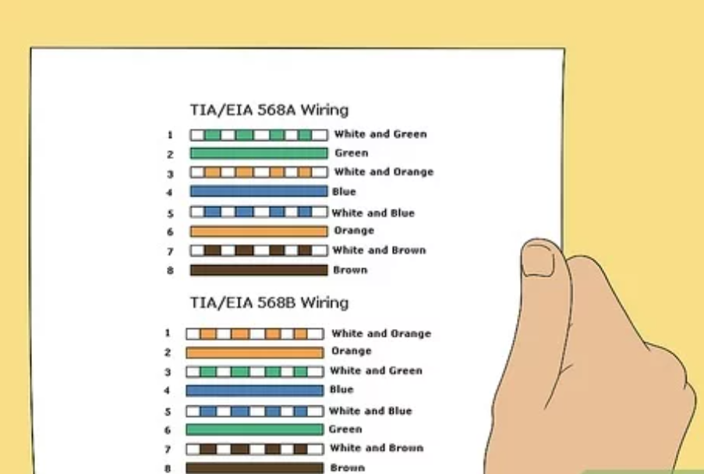

**Align the untwisted wires in the order necessary for your needs.** For this scenario, you'll be making a straight-through cable, which has both ends of the cable with the same alignment of wires, so it's easy enough to do. Since this is your first cable, we'll consult the cheat sheet to know what order we're aligning in!

**4**

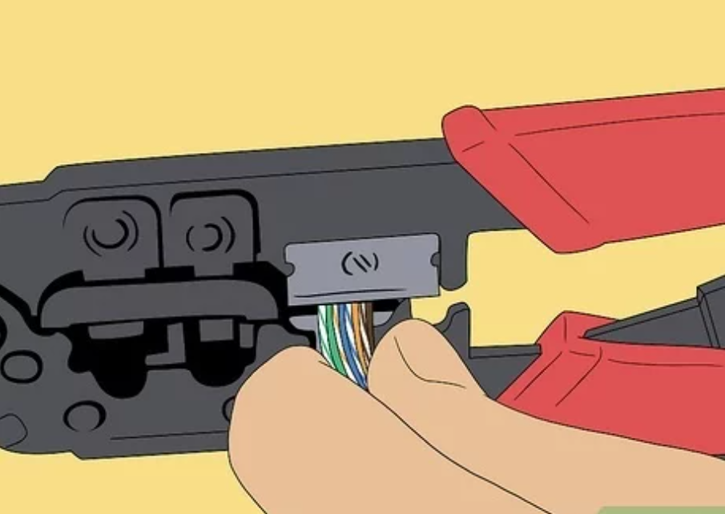

**Cut the extra wire.** Once you've untwisted the wires, you'll have a superfluous amount of copper wiring left; we don't need this much, but it's good to have it in the previous step to help in aligning the colors properly. Use the wire-cutting scissors to cut these off.

**5**

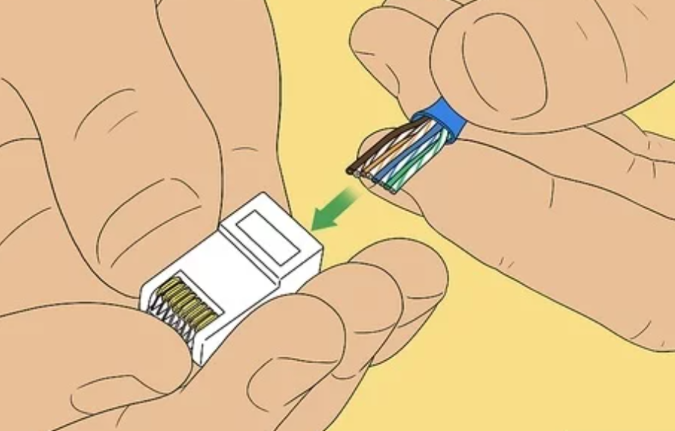

**Push the remaining wires into the RJ45 head.** Be careful not to bend the wires while pushing them in or you run the risk of creating a bad cable. You also don't want too little or too much wire left in the head; there's no definite length necessary, but it's pretty obvious to tell if there's too much cable or not enough. A short length of the jacket should be up the RJ45 head; use this knowledge as a reference.

**6**

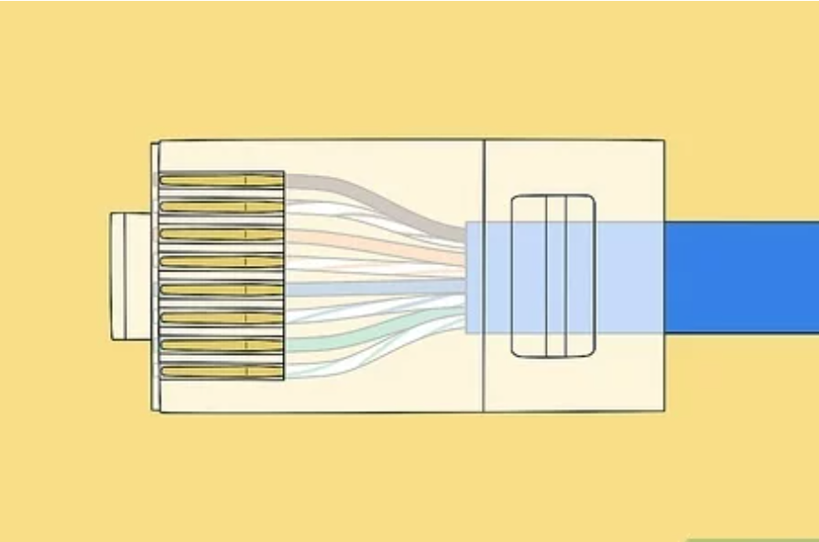

**Double-check that the wires are all the way up into the gold pins of the head and made it up in the proper order.** (Consult your cheat sheet if needed!)

**7**

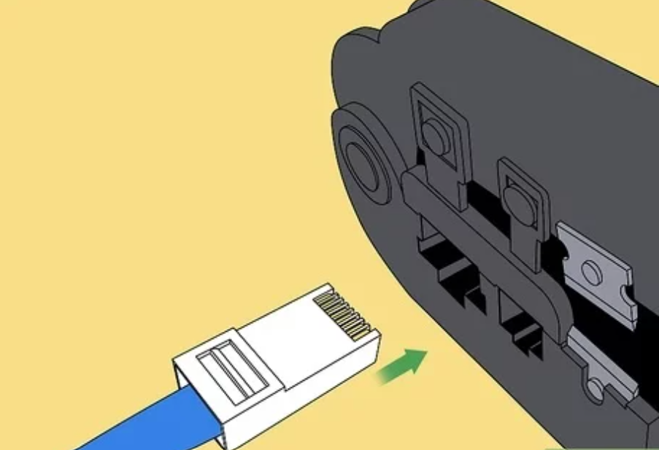

**Push the head into the open space of the crimping tool and squeeze it closed, hard.** If you don't crimp the cable all the way, the head may come off.

**8**

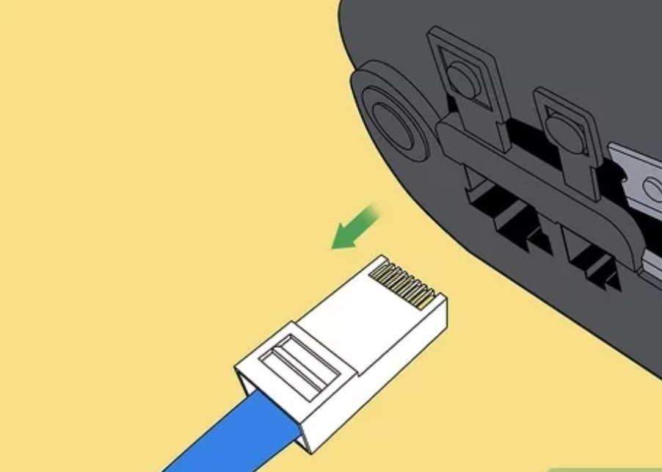

**Open the crimping tool and remove your newly-crimped Ethernet connector.**

**9**

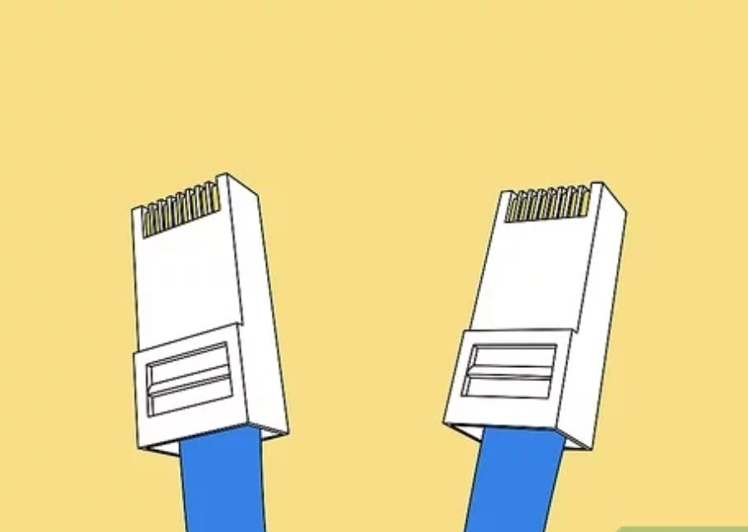

**Repeat the crimping process on the other side of the cable if you're making a completely new cable.** If you're repairing one end, this won't apply to you, so move on.

**10**

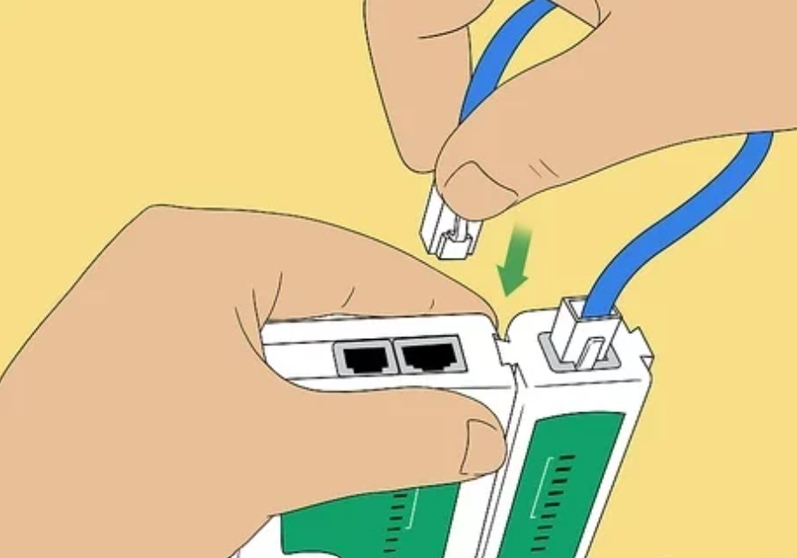

**Plug one end of the cable into the tan, two-port end of the cable tester, and the other end into the other part of the tester with the graphic display window.** Turn it on and listen for the beep. If it beeps once, you successfully made an Ethernet cable; if it beeps twice, some part of the cable is messed up and needs repairing. Depending on the error, the cable may or may not still be usable.

**11**

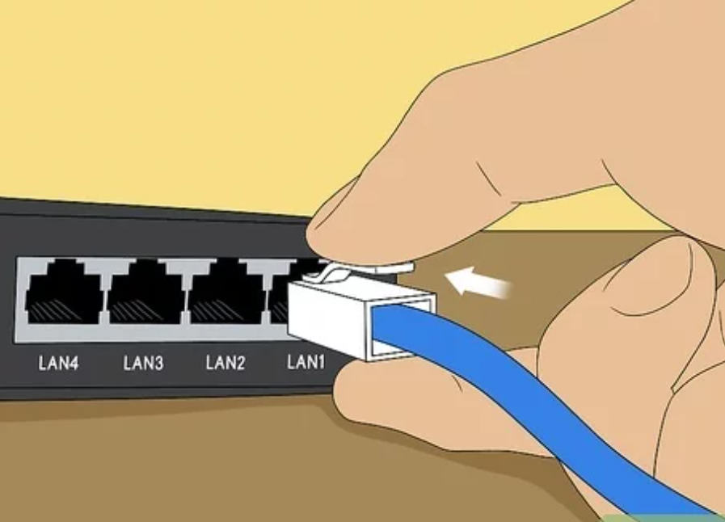

**Plug your Ethernet cable in.** Now that you've made an Ethernet cable all by yourself, you can connect all kinds of devices together!

1. **Result/Output/Writing Summary:**

Successfully created the connector to make a ethernet connection possible.

**Learning outcomes (What I have learnt):**

1. To make a ethernet connector.

2. Learnt about different transmission medias.

**Evaluation Grid (To be created as per the SOP and Assessment guidelines by the faculty):**

|  |  |  |  |
| --- | --- | --- | --- |
| Sr. No. | Parameters | Marks Obtained | Maximum Marks |
| 1. |  |  |  |
| 2. |  |  |  |
| 3. |  |  |  |
|  |  |  |  |